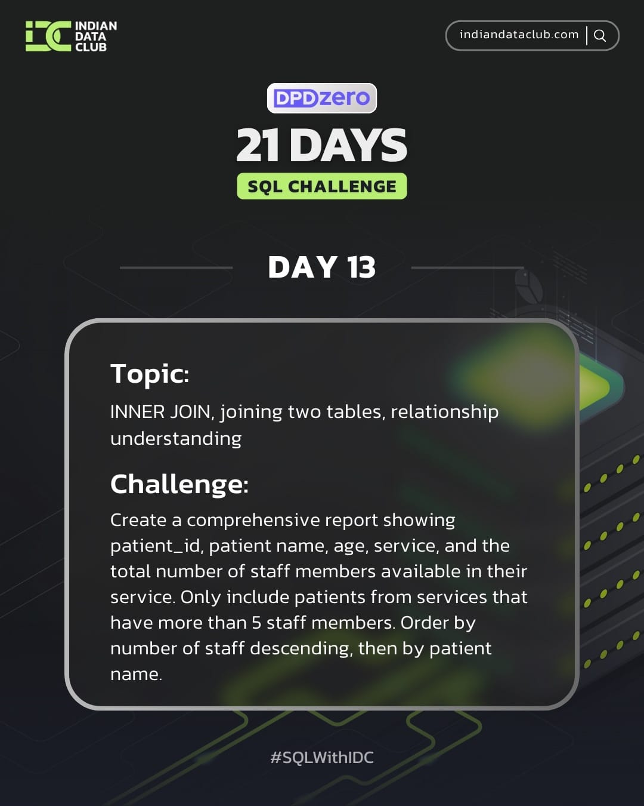
Day-13 SQL Challenge
Day-13 Challenge:
Create a comprehensive report showing patient_id, patient name, age, service, and the total number of staff members available in their service. Only include patients from services that have more than 5 staff members. Order by number of staff descending, then by patient name.
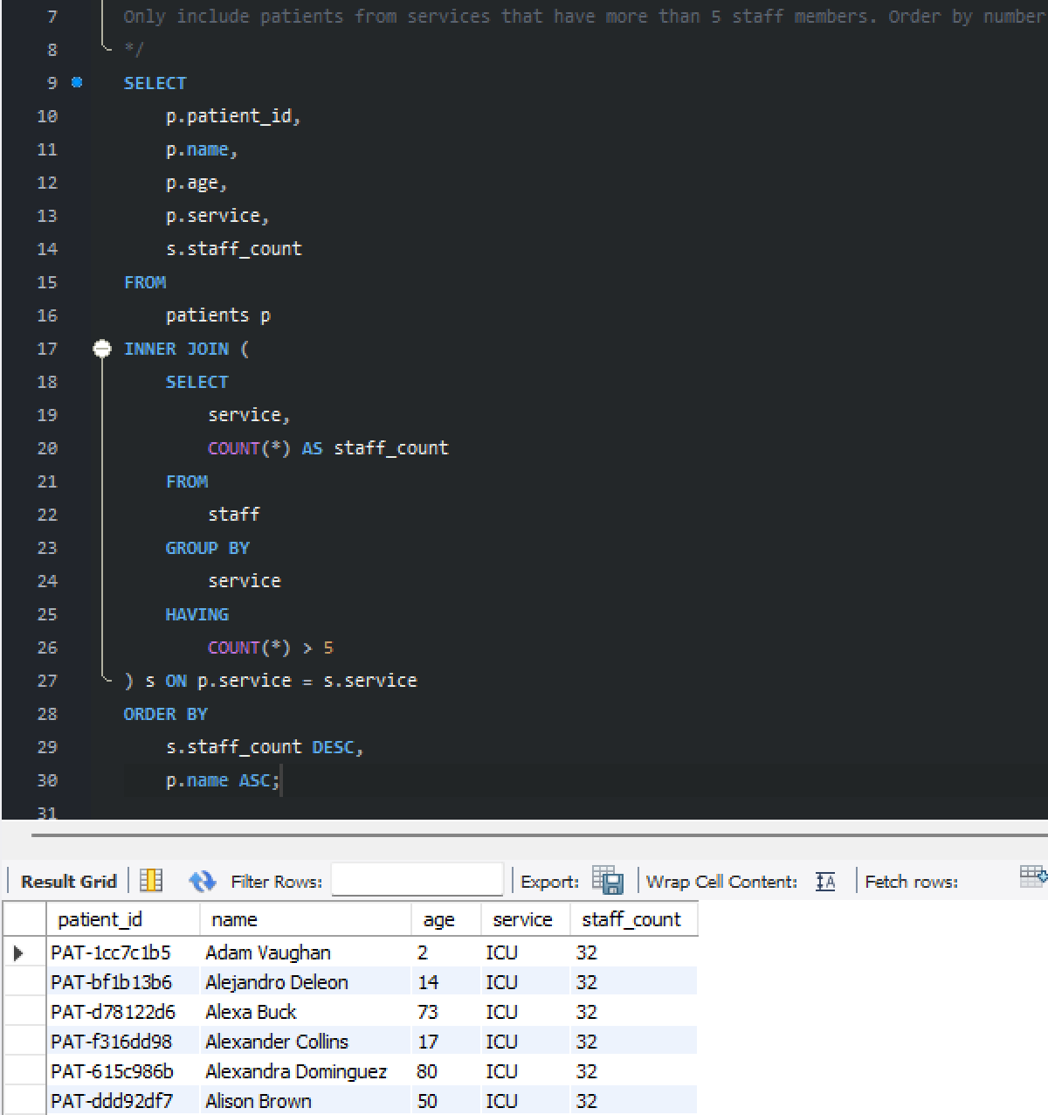
Practice Questions:
1. Join patients and staff based on their common service field (show patient and staff who work in same service).
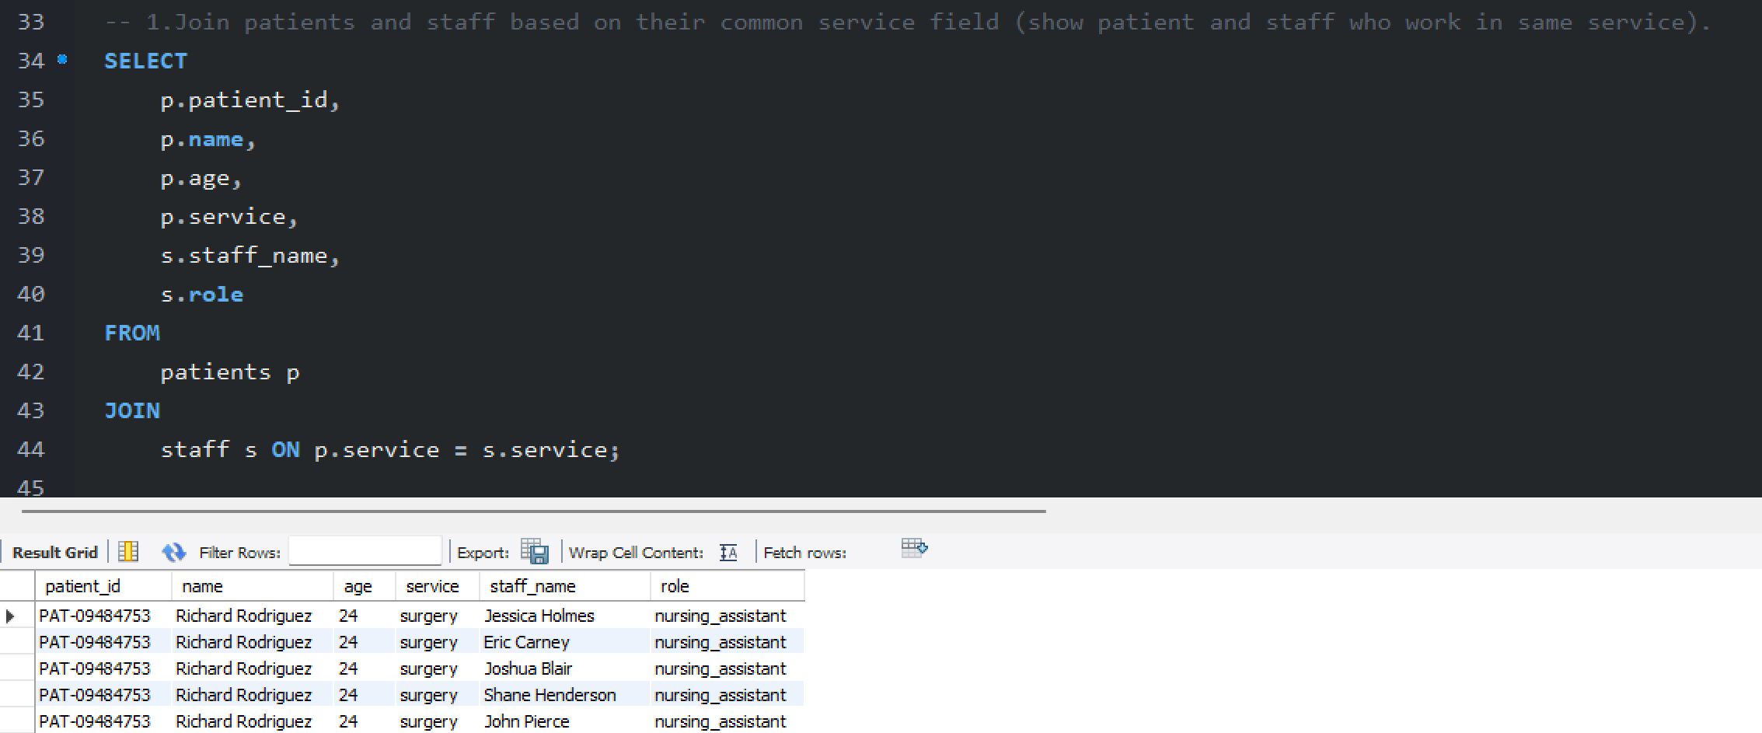
2. Join services_weekly with staff to show weekly service data with staff information.
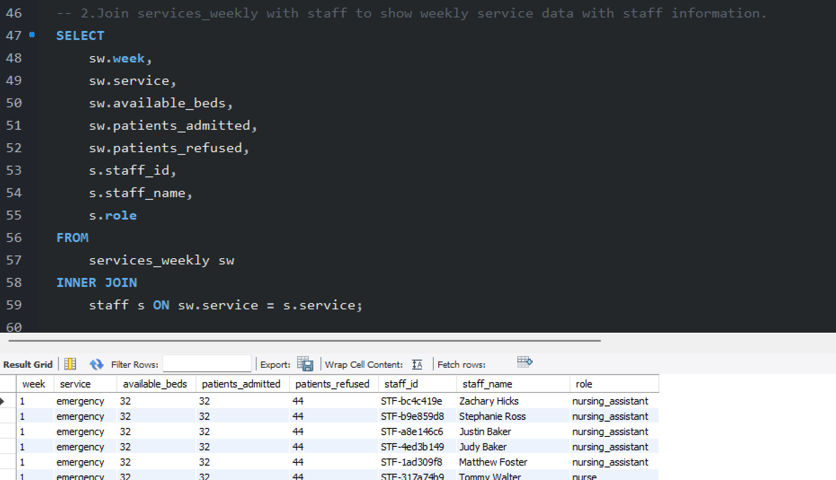

3. Create a report showing patient information along with staff assigned to their service.
